Activity Title | Planet Earth
Activity Overview | In this activity, you will apply practical movement based on Earth and elements of nature
Activity Worksheet
Warm Up - Complete the following 5 moves for 60 seconds.

Exercise | Describe
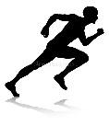  Exercise 1 – Sprint | On the spot lifting the knees and pumping the arms as fast as you can.
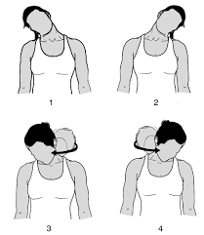  Exercise 2 – Head roll | Roll the head right to left for a count of four, nice and slow.
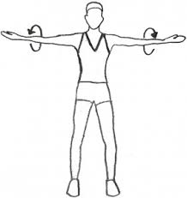  Exercise 3 – Arm Circles | Circle the arms forwards. Starting small and getting bigger.
Exercise 4 – Arm Circles | Circle the arms backwards. Starting small and getting bigger.
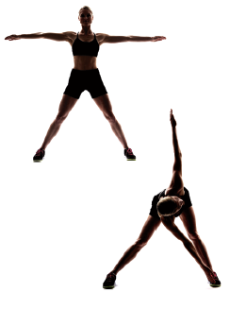  Exercise 5 – Alternating toe touch | Standing shoulder width apart, reach down to alternating toes.

Earth – Ground based poses to feel close to the earth

Lotus

In a seated position with crossed legs, arms rest open on the knees, spine straight.
Cat
Knees and palms in line and stable, arch back upwards.
Cow

Knees and palms in line and stable, arch back downwards, lifting the neck up.
Cobra

Body out straight across the floor, bring hands to side of shoulders and push the chest up.
Prayer / child pose

Sit back onto the heels and stretch out the shoulders, spine and lengthen the arms.

Water – Each move is based on a Tai Chi Move using the arms. The moves should be soft and flowing just like water. The moves should be held for one minute each. Stand in a deep squat to begin.

Trickle of water - Breathing lifting arms up and down
Flowing stream - Move the arms from side to side, right then left.
Water cycle – moving the arms in a figure of eight.
Imagine a soft rain cloud filled with water in your hand – move it from left to right, slowly and carefully.
Stroke the waterfall - reach to the side with both arms and stroke down, alternate from side to side.

Fire –strong yoga moves based on inner fire of a warrior. Each move should be held for one minute

Warrior 2
Front leg should have a bent knee and the back foot straight and foot turned out, lift the chest and spine head facing forward facing arm.
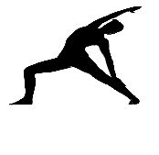 | Sun warrior  Feet stay in the same position as warrior 2. Front arm reaches over and learn towards back leg.
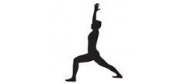 | Warrior 1  Both feet face forward, front knee is bent. Arms reach up to the sky.
Warrior 3
Stand on your right leg keep it straight and straighten out the body to extend as far as possible.
Triangle Stance
legs wide – reach down the left leg and open up the chest and straighten the right arm.

Air – Based on Yoga moves sun salutations. Movement around the sun. The air surrounds the sun, keep the moves light and flowy like the air we breathe and try complete them in sequence.

Extended mountain
Feet shoulder width apart, lift the arms up to join together at the top.
Forward fold
Bend the knees, upper body folds down, head joins knees and legs straighten.
Down dog

Both hands down, pushing down into the heels.
3 legged dog

Both hands down, pushing down into the heel, lifting one leg up, hold.
Lunge

Leg flows forward between the hands, drop the back knee down to the floor, lift the arms up.

Space – Balances against the force of gravity

Intense pose

Bend the knees and reach forward, for a challenge go up on the toes
Falling angel

Lift the leg out in front of the body and hold, lean back if you can.
Tree pose

Lift one leg to you ankle, knee or thigh and hold still.
Dancer

Take the right hand to the inside of the right foot, bend the knee and reach forward.
Head stand

Place the hands wide and place your head in between, lift the knees up and get your balance, once balanced straighten out the legs and point the toes.

Challenge
- Create one new pose for each category and describe how to do it and why you chose it.

- Upload pictures of yourself doing one move from each category on your Instagram and Tag Concord Summer Instagram #PlanetEarthChallenge

Earth | How do you do it?  Why did you choose this move?
Water | How do you do it?  Why did you choose this move?
Air | How do you do it?  Why did you choose this move?
Space | How do you do it?  Why did you choose this move?

