Activity Title | Dear Me: A letter to my future self.
Activity Overview | In this activity, you will think about the future and write down some key goals for you to achieve in 5 years’ time. You will learn how to write an effective letter. Then, you will write a letter to yourself in five years’ time.
Activity Worksheet
Part 1 – Thinking about your goals, and writing them down

First, watch this video from youtube. It will give you a great idea about what you need to do, and why it’s a good idea to do it!

https://www.youtube.com/watch?v=eTCP0O-LIyc

Activity 1(a): Brainstorm your ideas.

- Use the space below to draw a brainstorm. Write down some specific goals you would like to achieve by 2026 (5 years) or by 2031 (10 years). Let’s stick to a maximum of three goals, as you will need to think quite deeply about each one. Here’s an example for you:

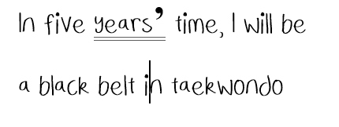

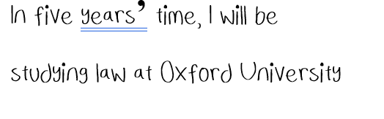

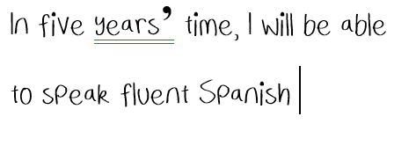

Draw your brainstorm here:

________________________________________________________________________________________

Part 1(b): Write down why you want to achieve each goal.

For each goal you have set yourself, think about why you want to achieve it. What does it mean to you? Will it bring you more confidence? Will it help you to build skills for a future job you would like to do? If the goal is to be doing a specific job, how would that make you feel and why do you want to do it?

For example:

Goal 1: In 2030, I will be teaching History in a secondary school.
Why? – Because I am passionate about history and want to share my passion for it. I enjoy talking to people about history and continuing to learn about it independently. I will find it rewarding to help students learn not only about the subject, but about how to write great essays and communicate their ideas effectively.

Use the space below to write why you want to achieve your goals.

Goal 1:
Why?

Goal 2:
Why?

Goal 3:
Why?

________________________________________________________________________________________

Part 1 (c): Write down how you think you could achieve these goals, by building good habits now:

Remember: don’t be vague! You need to have a specific idea of how you can achieve this. Don’t just say “I will work very hard!” For example, if you want to speak fluent Spanish, say “I will practice for ten minutes a day, 5 days a week.” Make sure that this is a realistic habit to have. For example, don’t say “I will study Spanish for 3 hours a day.” This would be difficult to maintain and may demotivate you if you cannot follow your plan.

Use the space below to write how you will achieve your goals.

Goal 1:
How?

Goal 2:
How?

Goal 3:
How?

Part 2 – How to write your letter

- Writing style:

Keep your writing style informal. As you are writing to yourself, there is no need for formal language. For example:

Hello! How are you doing? How have the last five years been? Has much changed? Do you still like photography? Do you still want to travel the World?

- Make sure to practice using correct grammar to talk about the future (see the example below):

- You might want to use the future continuous, e.g. “in 2026 I will be studying law at Cambridge University.” You could also use the future perfect, e.g. “by 2026 I will have visited every country in Europe.”
- You could also use some informal expressions to make your writing flow, for example “anyway,” “by the way,” or “Oh, another thing I wanted to mention.”
- Using some phrasal verbs if you can think of any!

Anyway, I wanted to write down my first goal. In five years’ time, I’m going to be speaking Spanish fluently! And I will have visited Spain to practice!

Use the first paragraph to talk about your life now. In the future, it will be interesting to read back what you have said. It might be a good idea to ask yourself some questions about the future, for example. Here are some ideas of things you could talk about (see the example below):
- The things you like to do
- The things you don’t like to do
- Your feelings about the future
- Some questions for your future self about what the future is like.

I wanted to start this letter by talking about life right now, in 2021. Hopefully you will look back and find it interesting. At the moment, in 2021, we are still in the middle of the covid pandemic. It’s awful. Is that still going on in 2026? I hope not! I have hopes and dreams to travel the World, which is really difficult these days. I enjoy school but I hope to go to University and study something I am passionate about.

- Now write one paragraph on each specific goal you have set. In each paragraph, you should set out the goal, being as specific as possible. You must then write a little bit about why you want to achieve this goal. Also, you need to write down how you are going to achieve this goal. Perhaps this could be a daily habit, for example. Remember, be specific! When writing down how you will go about achieving a goal, it is better to be specific than vague. For example, if you want to pass your English, it would be better to say that you are “going to read one book every month and watch one English movie per month,” than to say that you are “going to work very hard.” (See the example below).

One goal of mine is to be in good physical health, in five years’ time. I love doing sport and because healthy is important to me. I want to take up new sports and keep improving my fitness. One day, my aim is to run a marathon! I am not fit enough to do it right now, so I am committing to start running three times a week.

You should now be able to write down a great letter to yourself. Use the space below to write the letter! LET’S GO!

