Activity Title | Gratitude & Affirmations
Activity Overview | Today’s session is all about exploring the art of journaling. You will explore noting down your thoughts, feelings and emotions and use them to compose a short letter of thanks to someone.
Activity Worksheet
Journal page 1

Journal down a short list of people who you are thankful too.
Who are you thankful to?

Rank them in order and choose the most important to you.

Journal page 2

Think about why you are grateful to them, what did they do to or for you or a family member…
(List below your ideas on why you are grateful to them)

Journal page 3

How did the acts of kindness make you feel?
(List several emotions you remember feeling at the time)

Journal page 4
Importance of positive people in your life.

Emphasise how important it is to have positive people in your life and how they shape our own personalities, thoughts, gestures, attitudes in society.

- It is to have positive people in your life because …
- It is to have positive people in your life
- It is to have positive people in your life

Letter template

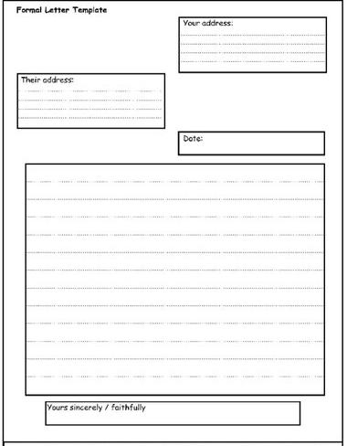

Structured paragraphs

How to write an effective paragraph.

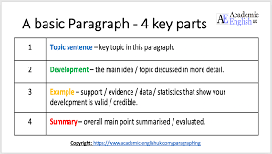

Writing Task

Complete a thank you letter in 30 minutes and submit it online to be in with a chance of a great prize for the best letter.

Writing Task

