Activity Title | Nutrition (Healthy Habits)
Activity Overview | In this activity, you will in this activity, you will learn the basics of nutrition (eat well) and how the food we eat, fuels our body.  Review the composition of food you currently eat and pledge to eat more of one food type
Activity Worksheet
Please can you write down the missing words on the first task:

F
P
C
M
V
D
F

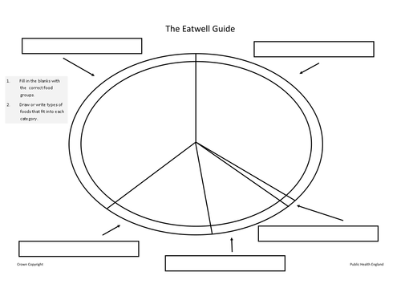
Can you put your answers on the Eatwell plate?

Describe the main categories of each component of a balanced diet:

This helps the because…...

You need to eat …... every day

What food did you eat this week?

Can you put the food you eat into the correct food group?

Sprinters can suffer injuries. A balanced diet can help recovery after injury.
What food group aids growth and repair?

What other food group can provide energy?

What type of food should he eat to provide energy?

Which food are you planning on eating more in the future and the reasons why.

