Activity Title | The Art of Improvisation
Activity Overview | In this activity, you will make a visual re-interpretation of your favourite song or piece of music.
Activity Worksheet
Have you ever considered what your favourite song or piece of music might look like? After today’s activity you will have a piece of art to complement your favourite song.

1) What’s the name of your favourite song or piece of music?

2) What do you like about this music? / Why is it your favourite?

3) How does this music make you feel when you listen to it? (For example do you feel happy, sad or excited?)
Here is a an example of a visual language of line, shape, mark and colour that could all be used to express how your favourite piece of music makes you feel.
4) Now let’s use this language to express different feelings. This will help us when we come to make a drawing of our music.
Sad:
Happy:
Now you are ready to make a drawing of your favourite song or piece of music. Remember to relax and close your eyes and let your imagination run wild!
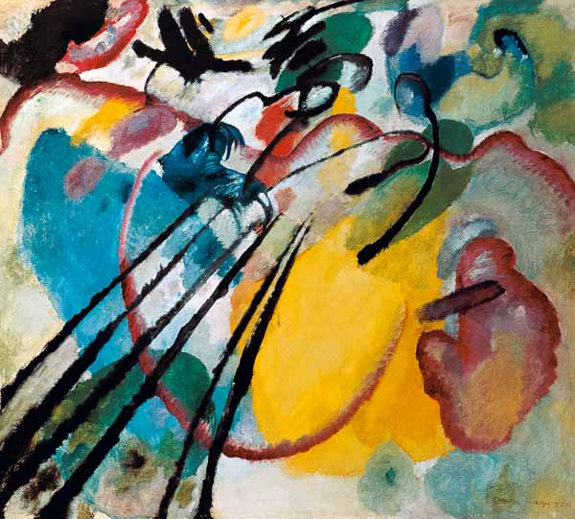
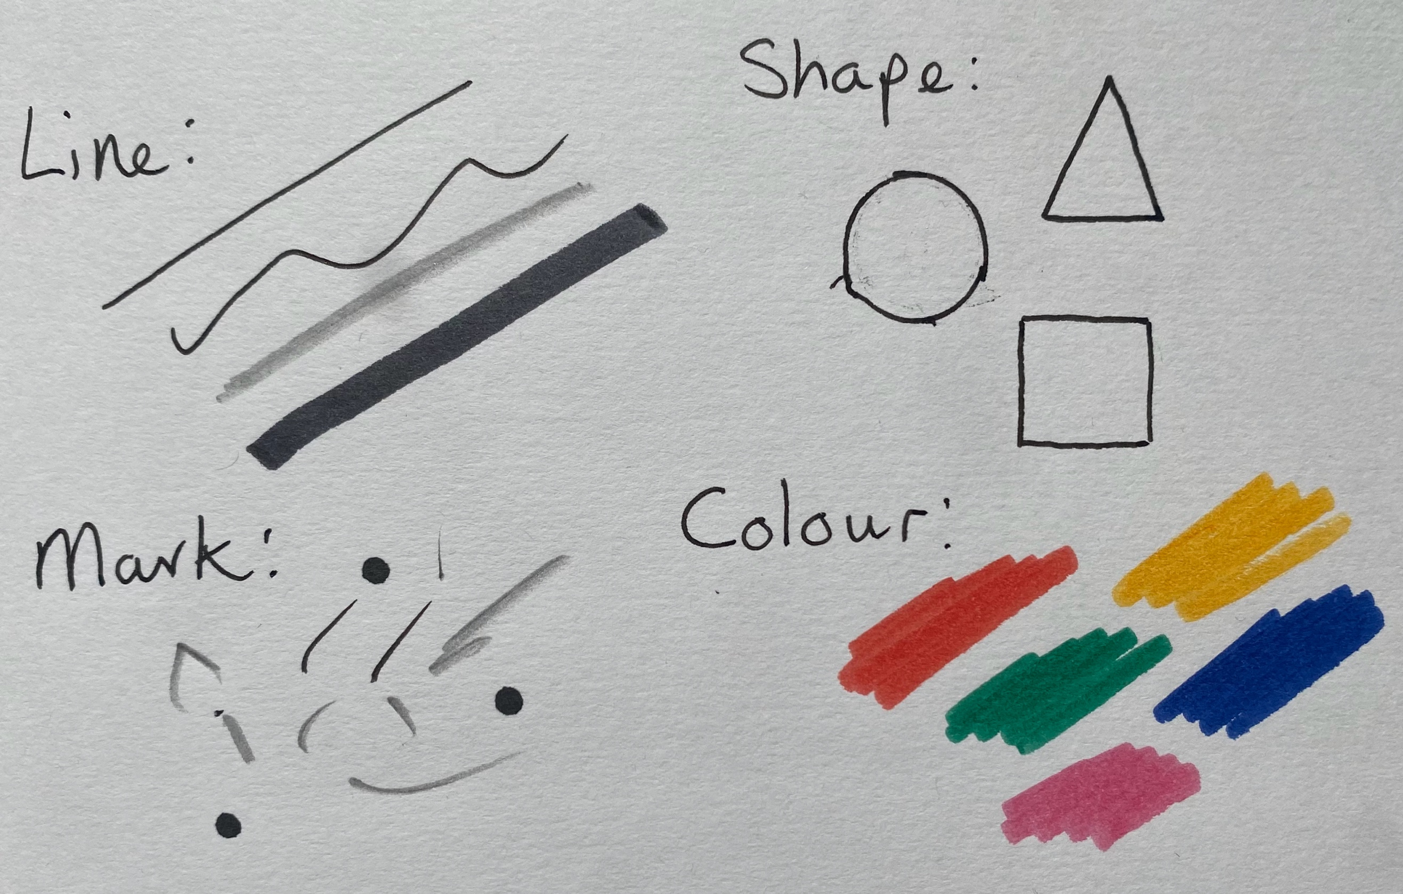
Here is an example to give you some ideas of what your drawing might look like. This painting is called Improvisation No.26 by the artist Wassily Kandinsky who was very inspired by music.

If you have enjoyed this activity, you could make more drawings of different types of music. See if a drawing of a Classical piece of music looks different to a drawing of a piece of Pop music.

