Activity Title | Global Perspectives
Activity Overview | In this activity, you will explore how art can be used to capture and communicate the feeling, emotion and culture of your local community.
Activity Worksheet
Have you ever thought about how art is so good capturing the feeling of a place, or the emotion you felt at a particular moment? Today you will explore all of these things and create your own pictures that communicate what your local community means to you.

1) What makes your local community special to you?
___________________________________________________________________________________________________
2) When you think of your local community, what immediately comes to your mind? For example, is it the people, the colours or the buildings?
___________________________________________________________________________________________________

Without taking any photographs yet, go for a walk in your local community. Really look around you, taking the time to stop and appreciate the sights and sounds that you are normally too busy to notice.
3) What have you noticed that you have not seen before?
___________________________________________________________________________________________________
When you have completed these questions, go for another walk, this time with your camera and take photos of these things that really communicate what your local community means to you. Could it be the food for sale in the local shops, or the flags flying above the buildings?

When you have taken your series of 10 photographs. You could try and edit them to make them more effective in communicating your ideas. Here are just two ideas to get you started.
Crop your photographs to tell a story: Use black and white or a colour pop to draw attention to the main subject of your picture
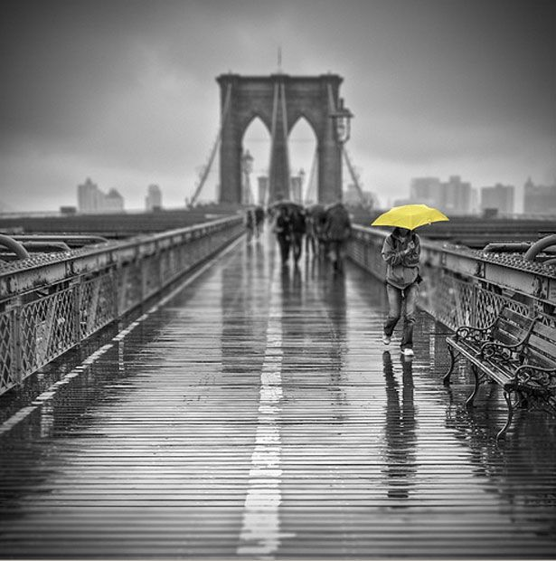
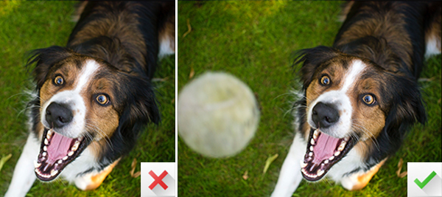

Now choose just 1 photograph that really captures the culture of your local community.

