Activity Title | Communication (The Art of Soft Skills)
Activity Overview | In this activity, you will learn about soft and hard skills and which ones will be useful for your chosen workplace in the future.
Activity Worksheet
Part 1 - Why do soft skills matter?

In the instructional video, Mr. Davies explained the difference between soft and hard skills. He also explained why soft skills are becoming more and more important. Please write down, in your own words, answers to the following questions.

What are Soft Skills?

What are Hard Skills?

Why do Soft Skills matter?

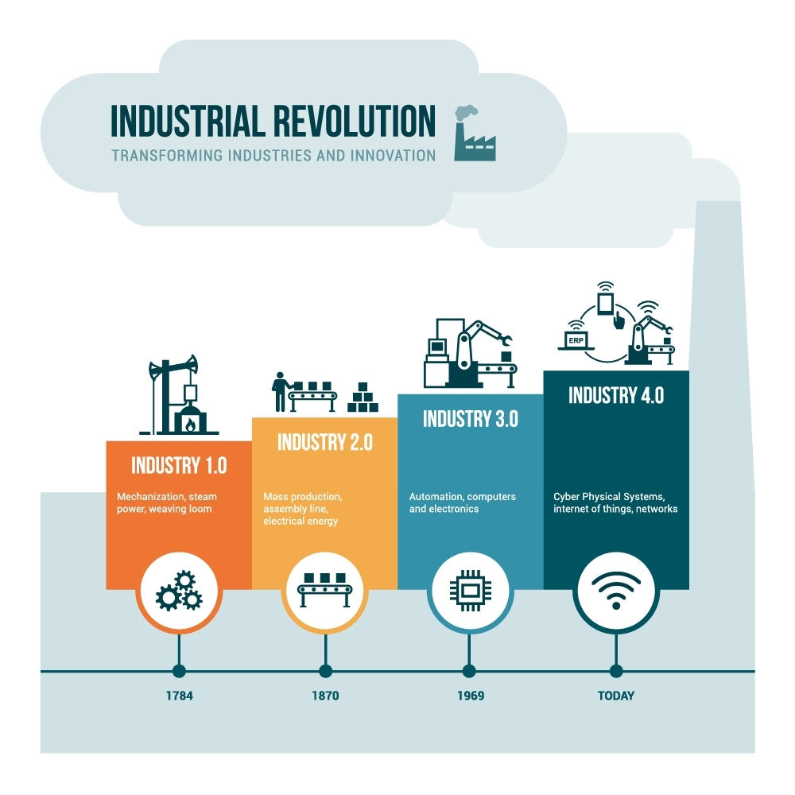
The Fourth Industrial Revolution and You!

Mr. Davies has already discussed the 4th Industrial Revolution in the instructional video. The following image highlights what the different industrial revolutions were and are. Goods over time have become cheaper and available to more people.

As you can see, the worlds is now at the beginning of the 4th revolution. It does not matter which sector you would like to work in or often what job you want to have. Industry 4.0 is and will change how goods are created and how services are delivered.

Please watch the following video
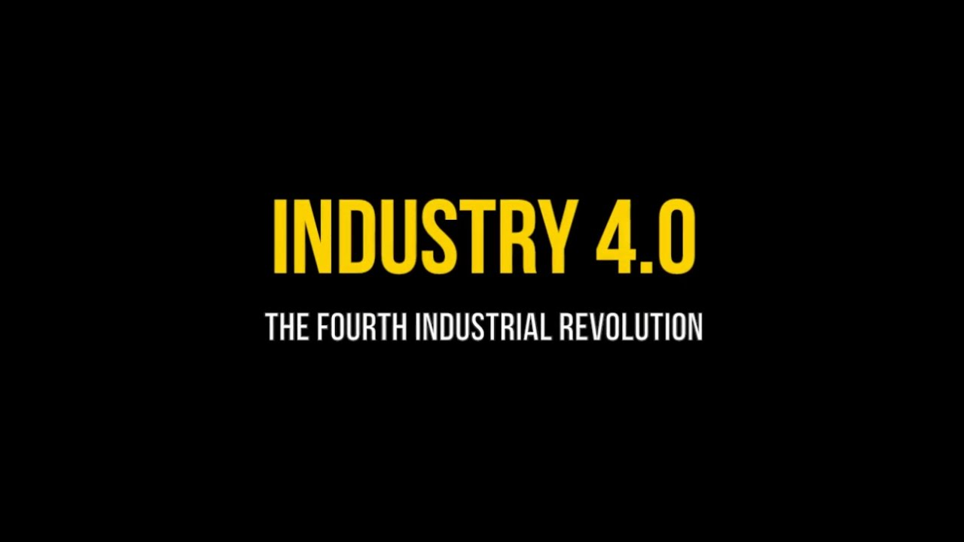

For example, what kind of sector would you maybe like to work in?

What kind of job would you maybe like?

How could the 4th Industrial Revolution change your sector and job? Use your imagination!

This is a small list of some of the soft skills which have become increasing important.
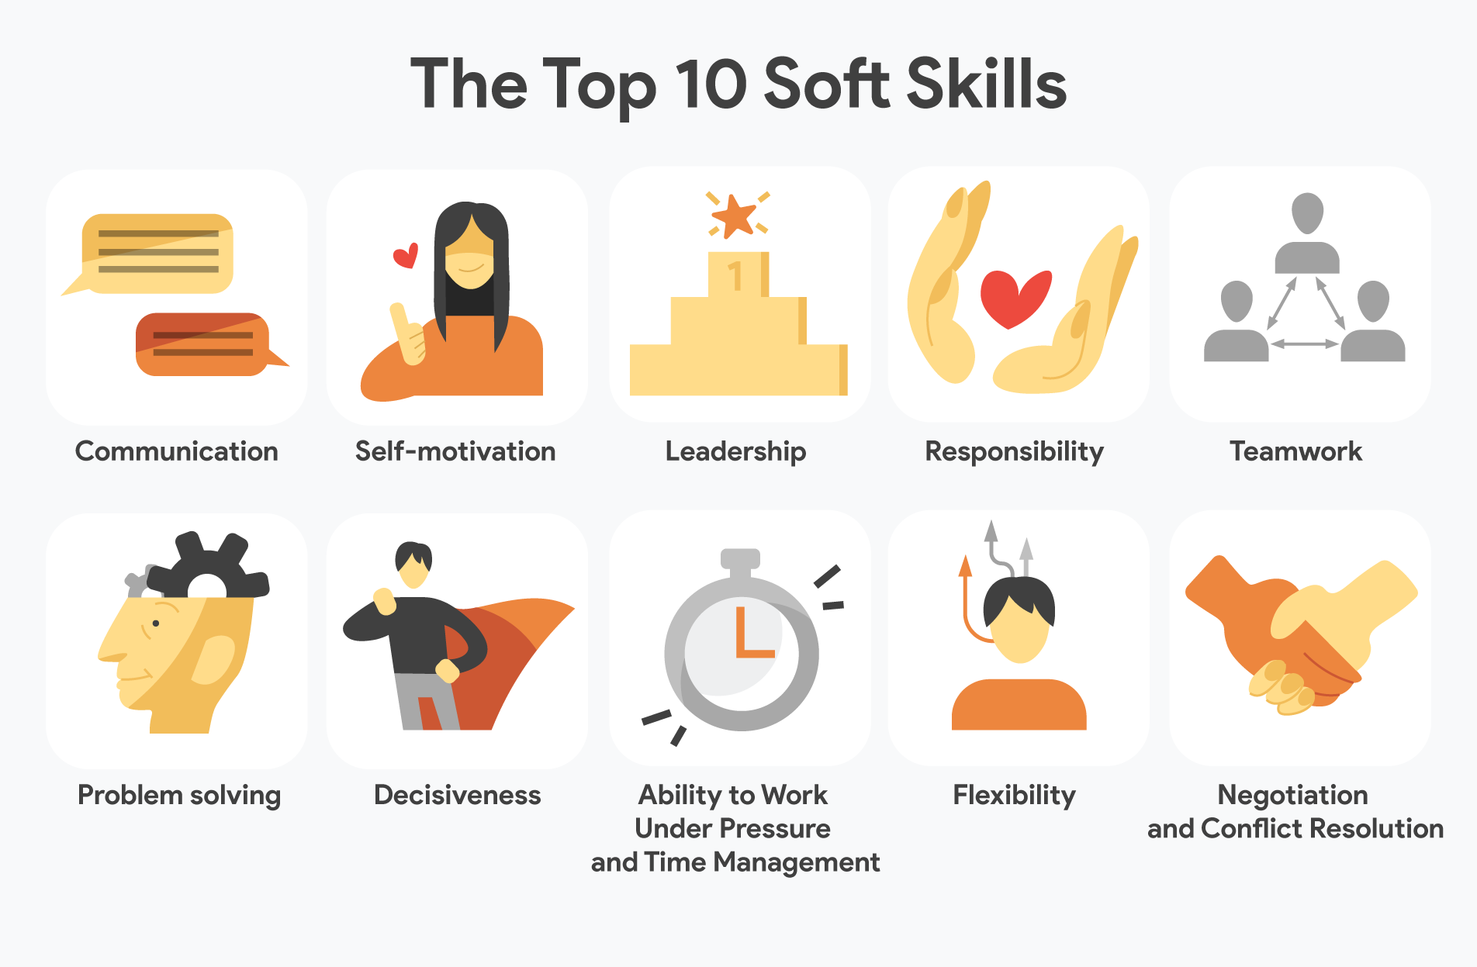
Type in ‘soft skills for the future’ into Youtube and watch some short videos

Which soft skills do you think could be important in your chosen sector and job? Why?

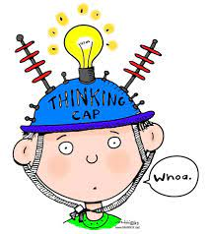
Make a plan and record an audio clip

- Choose three soft skills and complete your soft skills plan.

- Record a 1 minute audio clip that explains your soft skills plan.

What soft skill do I want to develop? | How will I know I have developed it? | What will I do to develop it? | How will I use my new soft skill?

Did I achieve my objective and learn about soft skills?

 | YES | Not sure | nO

Did I learn what hard and soft skills are?

Did I learn why soft skills are becoming more and more important?

Did I learn what a soft skills plan is?

Did I learn about what soft skills could be useful for me in the 4th industrial revolution?

