Activity Title | Time Management
Activity Overview | In this activity, you will learn how to manage your time when at school, to avoid distractions and to self-reflex on your studying habits.
Activity Worksheet

What is the meaning of Procrastination? Find the meaning in the dictionary and write down its definition.

Procrastination is…

Watch the video and do the following tasks:
https://www.youtube.com/watch?v=w4NsjnL4ieA

What is the title of an essay? (Tick the right answer)
- “What to do at a stoplight”
- “What not to do at a stoplight”
- “How to cross the road at a stoplight”
Tick the things SpongeBob is doing while writing an essay:
- Watching TV
- Doing exercises
- Shifting in his chair
- Watering flowers
- Feeding Gary the snail
- Tidying up the kitchen
- Washing the dishes
- Fixing the boat
- Phoning Patrick
- Drinking water and eating
- Talking to his neighbour
- Talking to the postman

Why is it hard for SpongeBob to start writing an essay?

It is hard for SpongeBob to start writing an essay because…..

List some tips on how to help SpongeBob write an essay relatively quickly
What should SpongeBob do? | What should SpongeBob not do?

Read what SpongeBob has learnt from Mrs. Puff about managing time effectively.
People procrastinate for different reasons. Mrs. Puff identifies three basic types of procrastinators:
Thrill-seekers, who wait to the last minute for the excited rush.
Avoiders, who may be avoiding fear of failure or even fear of success, but in either case are very concerned with what others think of them.
Decisional procrastinators, who cannot make a decision. Not making a decision prevents procrastinators from taking responsibility for the outcome.

How to tackle this problem:
Create a to-do list
Finish the hardest tasks first
If the task takes less than two minutes, do it right now
Set a period of time to do nothing but work
Give yourself a break
Remove your distractions
Don’t be a perfectionist
Motivate yourself by getting rewards
Get an accomplice
Focus on the end goal
Do one task at a time

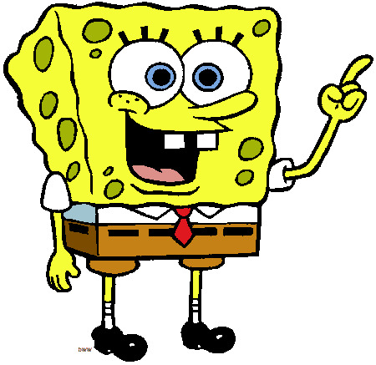

Jot down the activities you usually do on Saturday / Sunday apart from your homework (include all the small details)
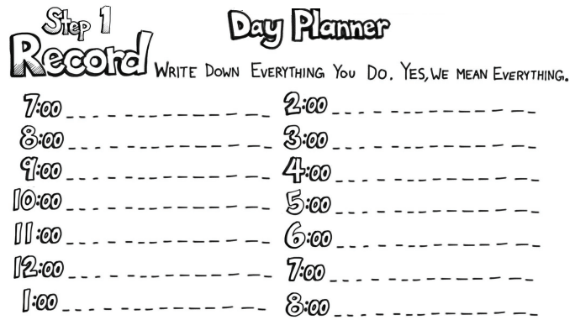

Pick your five biggest time-wasting activities and write them down
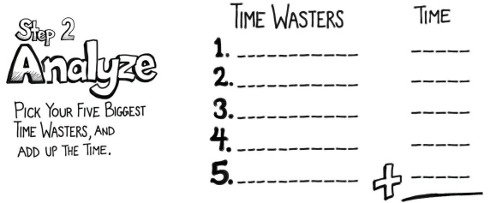

Total Time wasted: ____________________

Do you think you waste too much time doing unnecessary activities?

Write a composition of 50-80 words then upload this to Badgelist. What advice would you give someone to help them manage future assignments?

