Activity Title | What is Sustainability?
Activity Overview | In this activity, you will learn key skills that will help you market and sell your business.
Activity Worksheet
Part 1 - Starting your own business: What words do I need to know?

In your own words, please write what a good, service and sustainability mean.

Part 2– How can I make my sustainable business attractive?

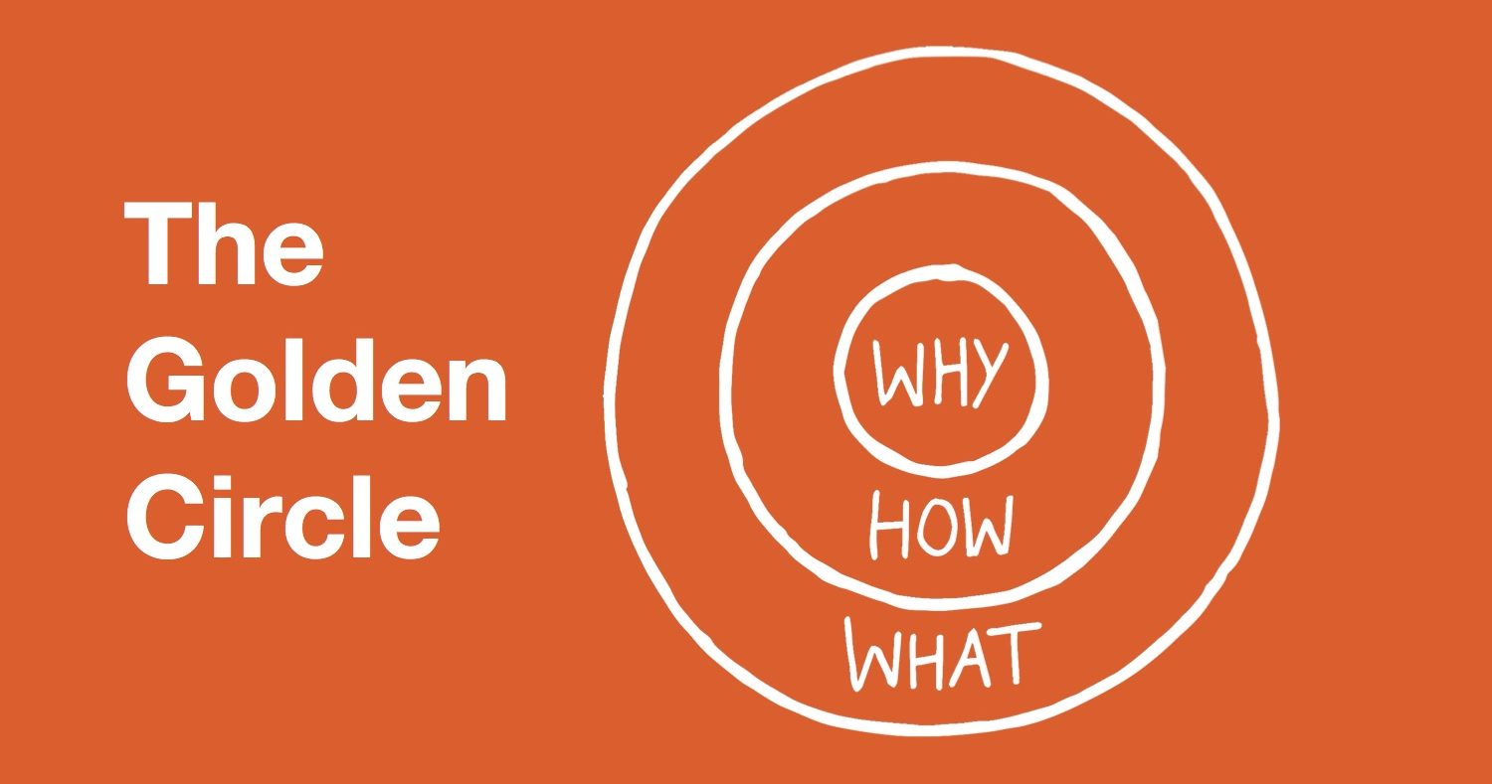

The Golden Circle is a way to make your idea attractive. This is called marketing. Many companies provide computers and phones but only a few, such as Apple, are successful. Apple clearly says why they do what they do. They ‘think differently’. I would like you to do the same.

You now know that it is important to explain the why, how and what of your good or service. However, your business should be sustainable. That gives you the WHY of your business. However, not only should your business ‘be’ sustainable, but it should also be produced sustainably. Please answer the following questions.
Time to choose your sustainable business

What is my sustainable business idea?

Why is my business idea sustainable?

How can it be produced sustainably?

Make your Golden Circle: Why, how, what!
Part 2 – How can I sell my sustainable business?
(Dragons’ Den - A popular British TV show)

You are going to make a pitch. A pitch is a short business presentation. It should be ‘snappy’ and ‘hook’ your ‘potential customers’ Body language, the structure of your pitch and the linking words you use are important. Please think carefully about how you look and how you say what you say.

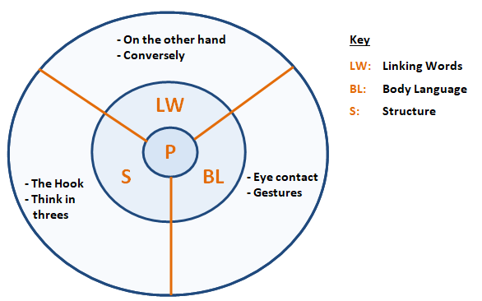

YouTube Activity - Watch Dragons’ Den pitches

There are some very good examples of business pitches on YouTube. Please type in the following words in YouTube ‘good pitch’ ‘bad pitch’ ‘Dragons’ Den’ and watch some clips.

Which pitches did I like or dislike?

Why did you like them?

Why did you dislike them?

Part 4 - LET’S DO IT!

Please make a pitch which is approximately 1 minute. Remember everything that you have studied so far. Please use the Golden Circles to explain why, how and what your business is, and also use it as a way to guide your structure and body language. Record it on your phone or camera and upload it :)

Part 5 - Did I achieve my objective to learn how to market and sell my business idea?

 | YES | Not sure | No

Have I learnt new business vocabulary?

Do I know how to give a sales pitch?

Do I understand marketing better now than before?

Do I understand what sustainable business means?

